WORKSHEET 2

BY AHMED MAMNOON

OPERATING SYSTEM (UFCFWK-15-2)

AHMED MAMNOON (S2200763)

VILLA COLLEGE

Lab Session 2

**Module Information:**

Module Name: Operating Systems

Module Code: UFCFWK-15-2

Module Tutor: Shancang Li, Ian Johnson, Laurence O'Brien

Ahmed Mamnoon

S2200763

Main tasks:

1. Download and build Binutils (a collection of binary tools)

2. Download and build a local version of GNU c compiler (GCC-5.3.0)

3. Use Git to fork/build/run a minimalOS

4. Modify the VGA driver to support newline/scrolling capability

5. Use Git to push your changes to your remote repo

GETTING STARTED

**SETTING UP THE ENVIRONMENT**

1. Creating directory for cross-tools, using the following command.

**Building Binutils (GNU Binary Utilities)**

1. Create directories $PREFIX/downloads and $PREFIX/source

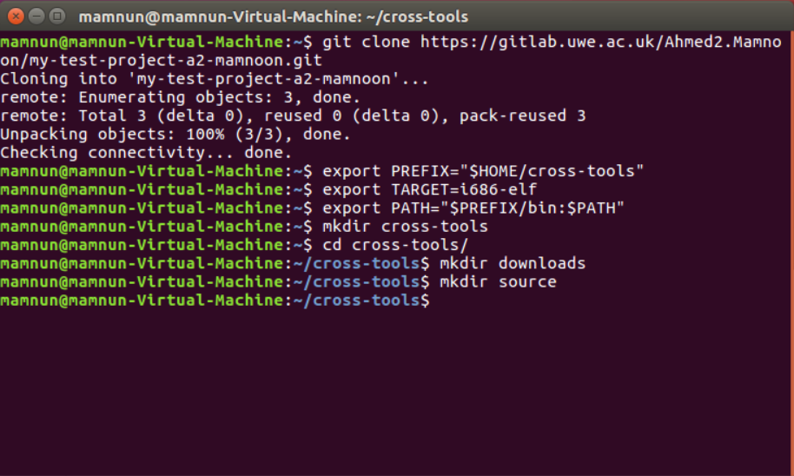

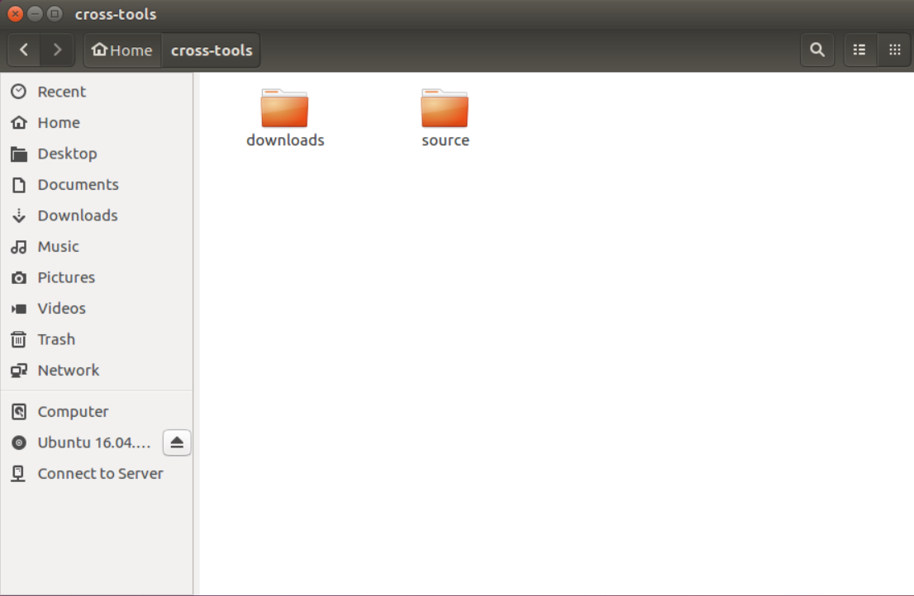

1. 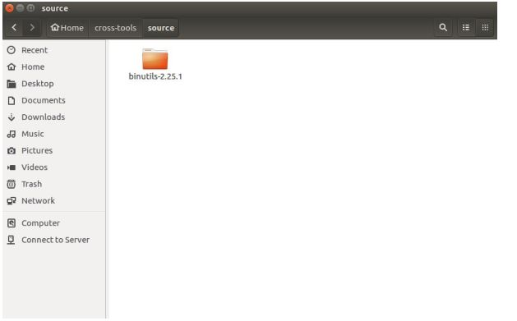Change directory to $PREFIX/source
2. Extracting Binutils source using command

tar zxvf ../downloads/binutils-2.25.1.tar.gz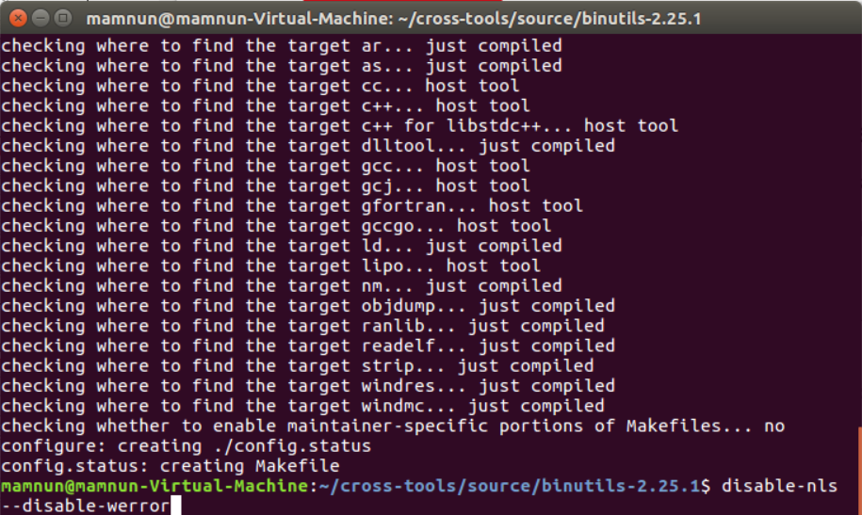

1. Change into the directory binutils-2.25.1. We now have to configure the Binutils

source so it can be built on the particular Linux distro.

./configure --target=$TARGET --prefix="$PREFIX" --with-sysroot --

disable-nls --disable-werror

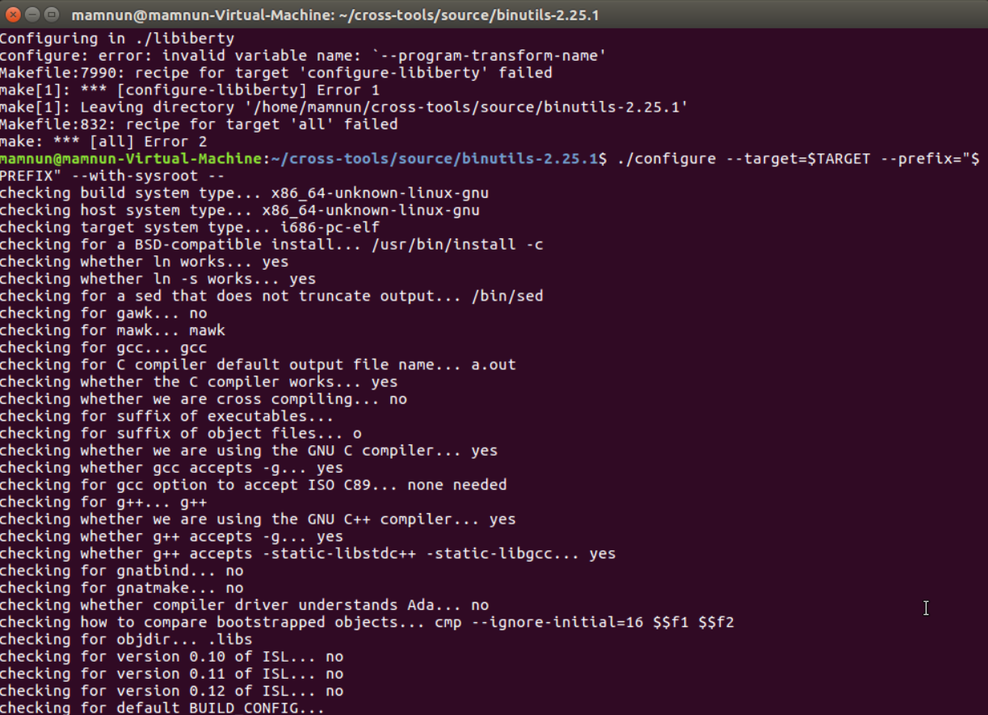

1. Now we build and install binutils with the commands, make and make install.

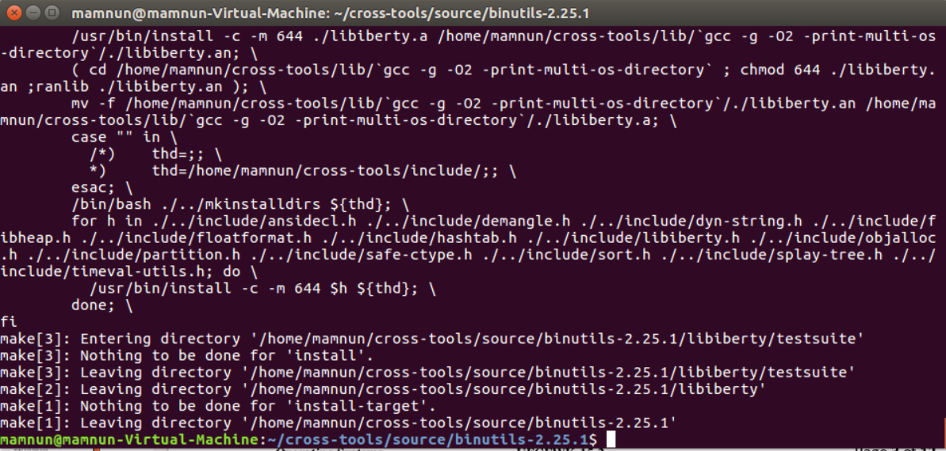

**GCC**

1. I have downloaded the latest version of GCC to downloads as mentioned below.

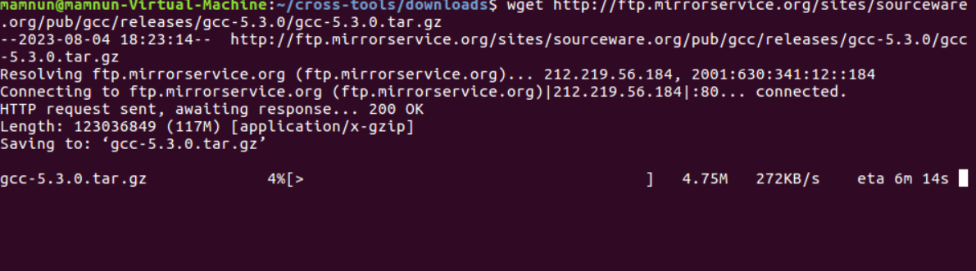

1. Create a new directory in the gcc source as follows

mkdir gcc_build

cd gcc_build\

../configure --target=$TARGET --prefix="$PREFIX" --disable-nls

--enable-languages=c,c++ --without-headers

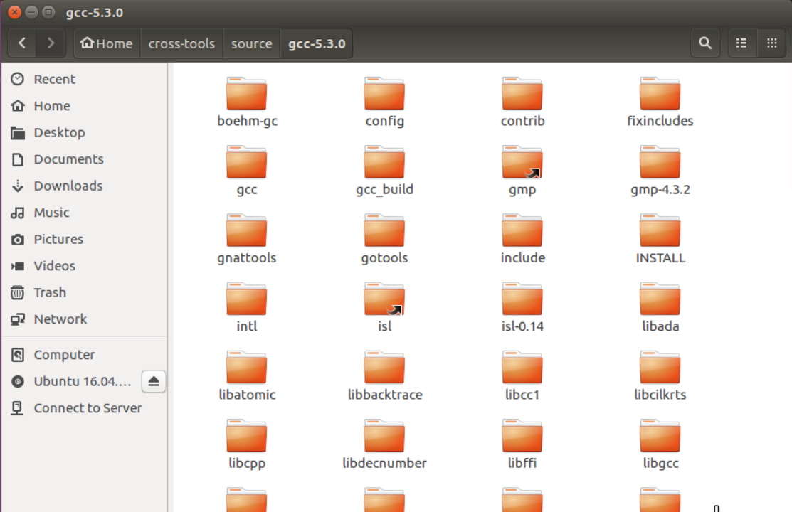

1. Build and install gcc and associated libraries:

make all_gcc



 make all-target-libgcc

make install-gcc



make install-target-libgcc

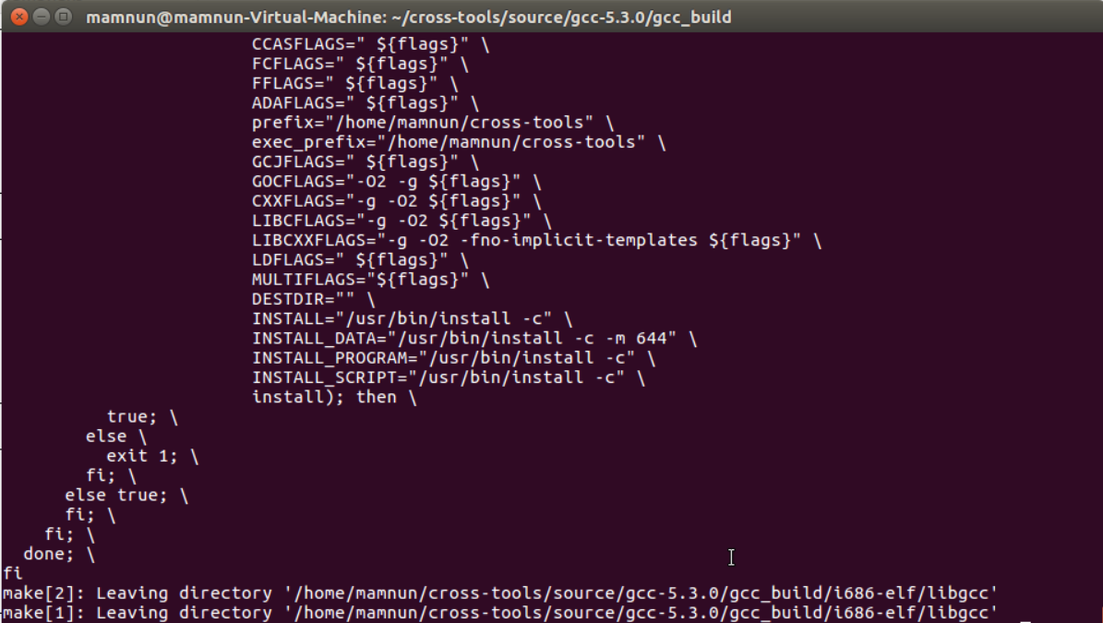

Download and build our minimal OS

1. Change into the directory $PREFIX/minimalOS

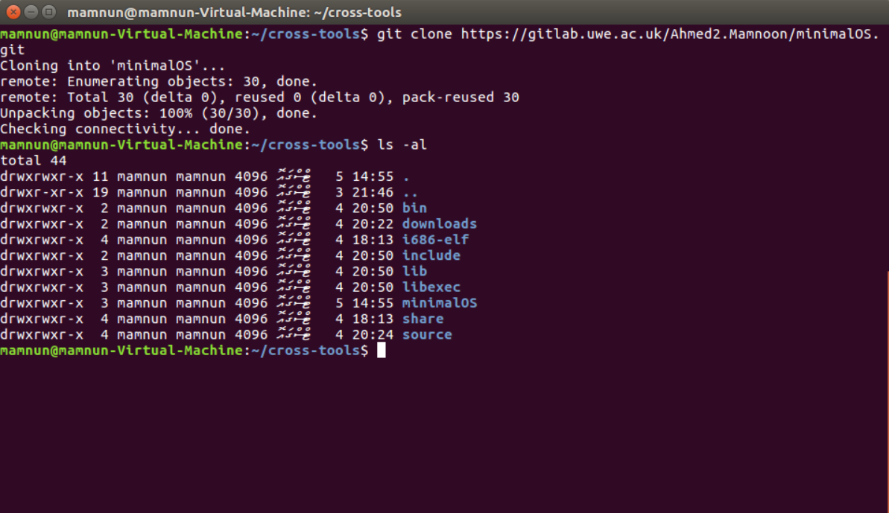

1. Creating a bootable image as follows:

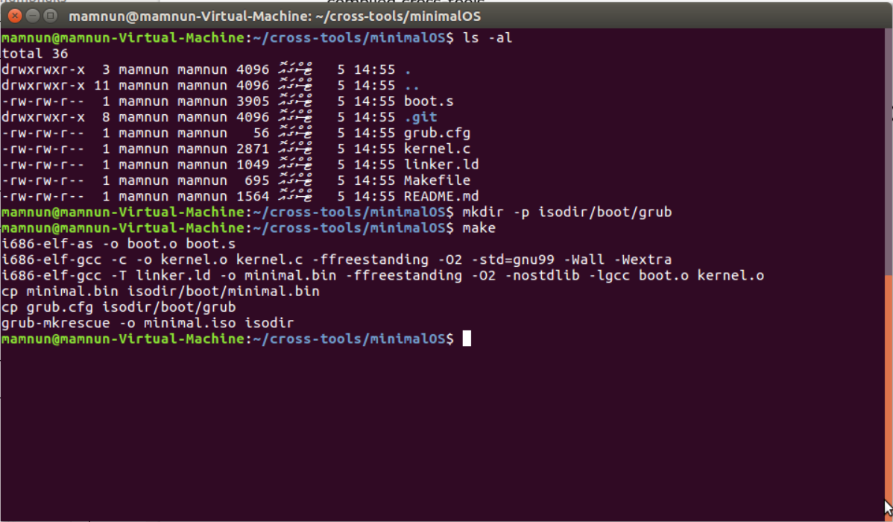

1. Now build the OS by commanding “make”

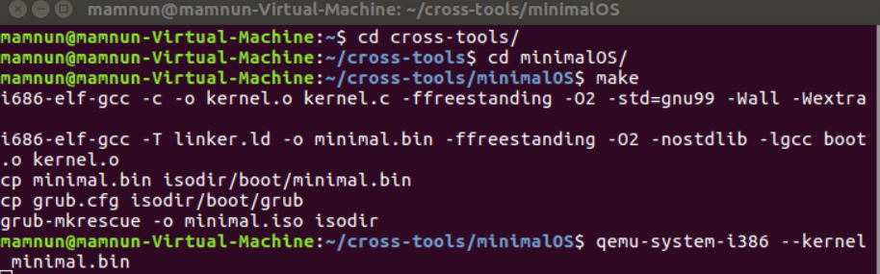

**Running our MINIMAL OS**

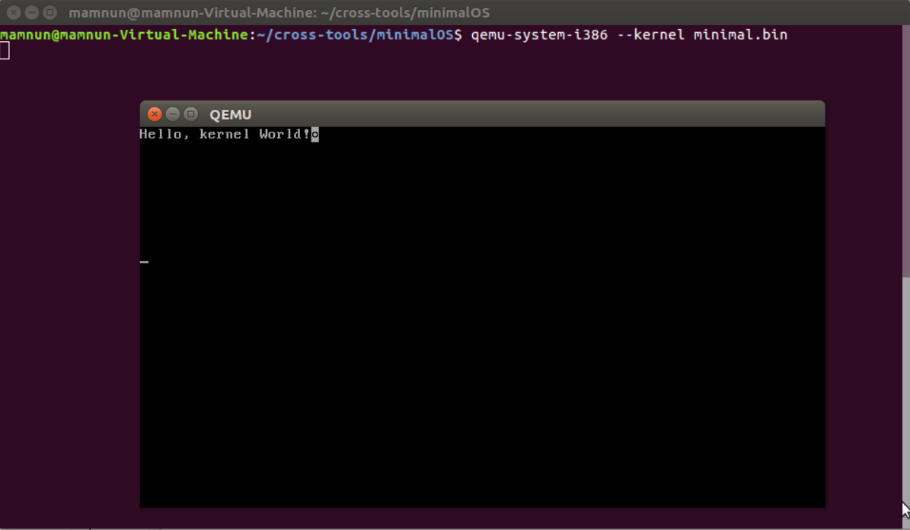

Adding additional functionality support to our VGA Driver

Here I have modified the VGA driver

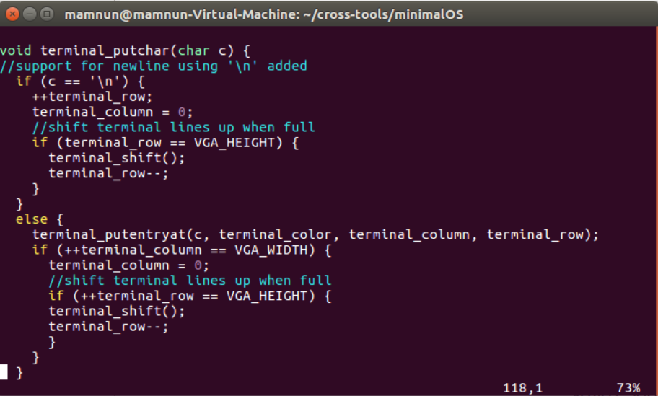

Here is the result

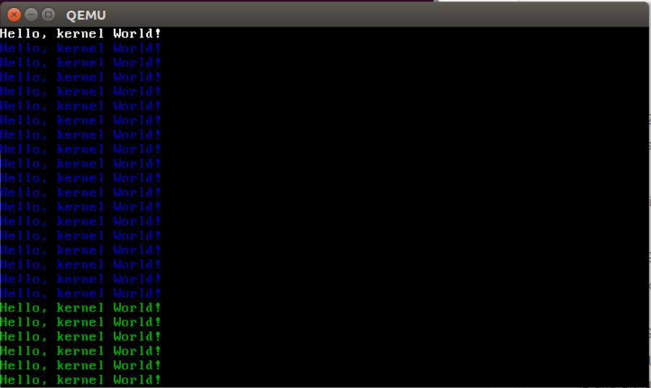

Finally, Push it to gitlab using command “git push”